Written Review

Student’s name and ID:
Date of submission:

SAMPLE/BÀI MẪU

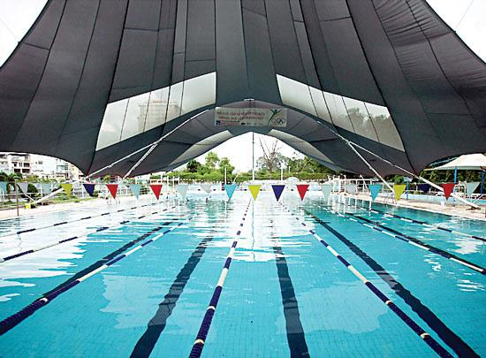
I’m a sort of person who cares a lot about health. Despite being up to my ears in work, I always try to make time to work out. Swimming is my favorite sport, and I choose Yet Kieu Aquatics Center which is located at 01 Nguyen Thi Minh Khai Street, District 1 to practice swimming on a regular basis. This center offers a lot of special features that you cannot find in any other one throughout the city. First and foremost, it has two large separate swimming pools, each of which has about ten wide lanes. Besides, it has a small pool which is designated for kids. Another thing I like about the center is the staff there are really helpful and friendly. Whether you are a newcomer or a frequent swimmer, they are always a great help. Last but not least, all the swimming pools are equipped with shades which cannot be found in any other pool in the city. That’s why swimming in the blazing sunshine is not a problem. If you are a big fan of swimming, come to Yet Kieu Aquatics Center and dive yourself in the pools. You’ll definitely feel all the more refreshed and rejuvenated.

