Exotic World

Student’s name and ID:
Date of submission:

SAMPLE/BÀI MẪU

Original version:  Woman finds lost ring wrapped around carrot  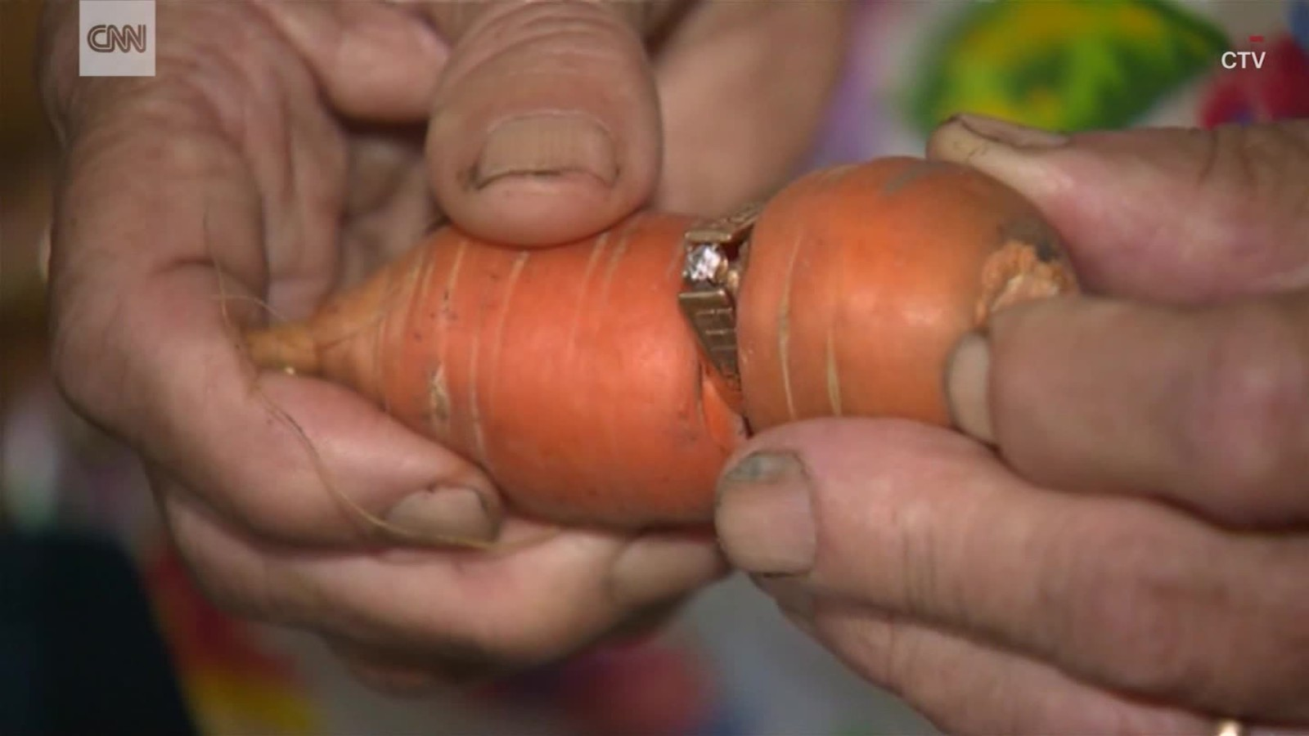  A long-lost engagement ring showed up in the most unexpected place. It was embedded in a carrot! Many years ago, Mary Grams lost the ring while gardening on her farm. After she couldn’t find it, she decided to get a replacement ring. 13 years later, Mary got a call from her daughter-in-law who found the ring in the garden, in the middle of a freshly-pulled carrot. Now, it’s back with Mary where it belongs. Mary admitted her late husband, who died five years ago, had never known the ring was missing.  Source: http://edition.cnn.com/videos/world/2017/08/17/missing-ring-found-around-carrot-orig.cnn | Summary:  The surprising return of a long-lost ring  Mary Grams’ long-lost engagement ring was found in the middle of a freshly-pulled carrot in the garden on her farm. Many years ago, she lost it while she was doing gardening there. After unsuccessfully searching for it, she decided to replace it with another ring. 13 years later, Mary’s daughter-in-law discovered her lost ring, which wrapped around a carrot. Now it is returned to its owner whose late husband had never known it was once missing.

