Written Review

Student’s name and ID:
Date of submission:

SAMPLE/BÀI MẪU

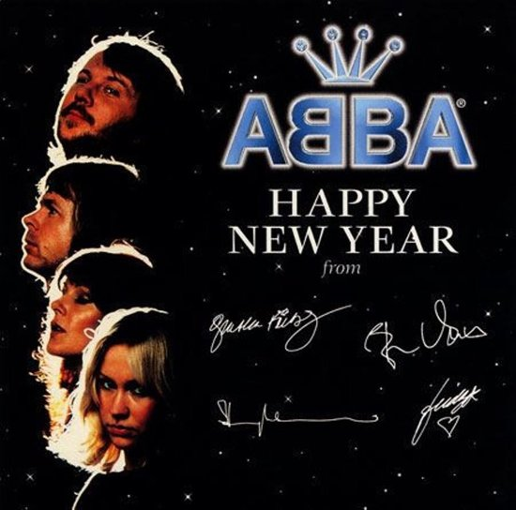  HAPPY NEW YEAR  No more champagne  And the fireworks are through  Here we are, me and you  Feeling lost and feeling blue  It's the end of the party  And the morning seems so grey  So unlike yesterday  Now's the time for us to say  Happy New Year  Happy New Year  ...  May we all have our hopes, our will to try  If we don't we might as well lay down and die  You and I | Song review  My favorite song Happy New Year was composed by ABBA, a famous Swedish band, in 1980. The song was harmoniously performed by two male singers and two female ones. Whenever I hear it, I feel that out Tet holidays are coming together with the wonderful change of nature. I especially like its melody which brings me a melancholy mood, the cause of which I can't explain. Strangely, this sad feeling never stops me from enjoying the song's perfect musical tune. Another good point is the lyrics. They carry an important message: although our future may not be as bright as we wish it to be, just be friends, hold hopes and look forward.

